Training Document for Teachers
Course Learning Outcomes (CLOs) are central to your course’s curriculum. A Course Learning Outcome (CLO) is a measurable, observable, and specific statement that clearly indicates what a student should know and be able to do as a result of learning.
To calculate Course Learning Outcome (CLO) attainment, we need to know the following:
1. What is the CLO mapping to a question?
2. What is the class strength?
3. What are the total Marks of the questions mapped to particular CLO?
4. What is the CLO threshold? – 60% or 6 marks out of 10 marks 5. What are the total marks scored by students for each CLO ?
Step 1: Map the Course Learning outcomes to the questions mentioned in the Continuous Assessment/ Semester End Examination Question Paper.
Example of the Question Paper:
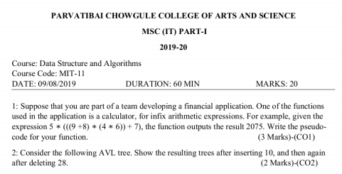
Step 2: Calculate the total marks scored by the student in the Continuous Assessment/Semester End Examination with respect to Course Learning Outcome. Enter the marks in the Excel Package’s Sheet No 3(i.e. Marks).
Consider the following data:
CLO  Mapping | CO1 | CO2 | CO3
Total Marks | 10 | 10 | 5
RollNo
SP192201 | 7 | 7 | 1
SP192202 | 4 | 4 | 2
SP192203 | 8 | 4 | 7
SP192204 | 7 | 6 | 2
SP192205 | 6 | 5 | 3

From the above data, Class Strength=5 and Total Marks for CLO1=10, CLO2=10, CLO3=5
Step 3: Finalizing the Threshold for Each Course Outcome.
1: Each Course Learning Outcome can have a different threshold value.
2: Threshold can be decided based on
- Average percentage scored by the students of the previous batch OR
- Eligibility Criteria of the Programme.

Consider threshold to be: 60% for CLO1
CLO 1’s attainment in above case is 80% because, 4 students are equal or above 6 marks (Threshold=60% for CLO1), therefore CO1 attainment = 4 / 5 * 100 = 80%
Rollno SP192201,SP192203,SP192204,SP192205 have secured marks more than or equal to the threshold specified for CLO1. Therefore these students have achieved CLO1.
Likewise, if you calculate % attainment of all the questions in all continuous assessment/Semester End Examination of your course, which are mapped toCLO1, and for example, you got overall 65% CLO attainment for CLO1 after considering marks of all Continuous Assessment and Semester End Examination.
For CO1, however, the institute might have set “Target% Attainment” as 55% and your overall CLO1 attainment is 65%, therefore, your CLO1 is said to be Attained at Class Level.
What is Level of Attainment?
Level of attainment is derived by finding out in which bucket the overall CLO attainment falls.
National Board of Accreditation has suggested 3 levels of attainment – 1, 2 and 3, which corresponds to Low, Medium and High in a way.
You can define the buckets for CLO attainment as shown below:
Level of Attainment
Level | 1 | 2 | 3
% CLO Attainment | 0 to 30% | 30 to 60% | 60 to 100%

Since your CLO1 has attained 80% attainment, it falls in 3rd bucket and hence, CLO1’s level of attainment is 3.
Likewise, you can calculate CLO attainment and level of attainment for all CLOs of your course. So, finally, you may come up with numbers like this:
 | CLO Attainment % | Level of Attainment
CLO1 | 80% | 3
CLO2 | 76% | 3
CLO3 | 55% | 2
CLO4 | 29% | 1

At the end of the each Continous Assessment teacher needs to prepare the action plan to improve the CLO attainment percentage.
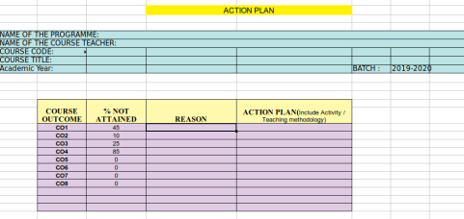

1: Marks Entry
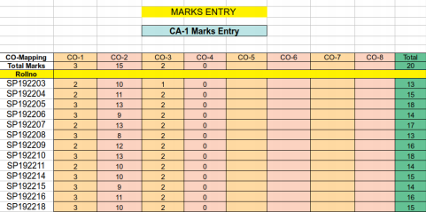

2: Setting CO threshold
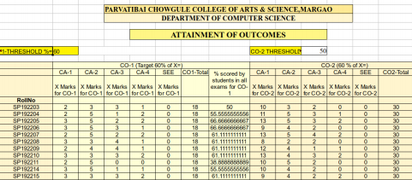

3: Analysis
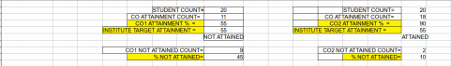

4: Level of Attainment
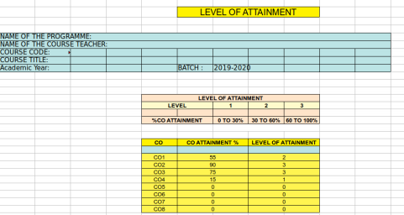4: Action Plan

